Designing for Social Media Using Canva

1. Introduction to Social Media Design
Social media design involves creating visual content that attracts attention, communicates messages clearly, and matches the platform’s style. Canva is a popular tool because it is easy to use and provides ready-made templates for social media platforms.

2. Creating Instagram Posts & Stories in Canva
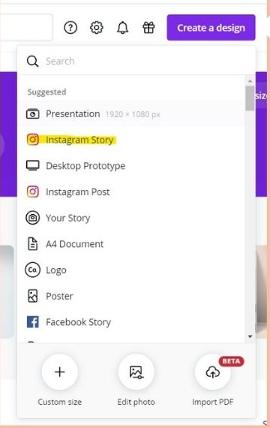
Instagram Posts
- Used for sharing images, promotions, quotes, and announcements
- Standard size: 1080 × 1080 pixels (square)
- Canva provides templates for:
  - Promotional posts
  - Quote posts
  - Carousel posts
Steps in Canva:
- Open Canva
- Select Instagram Post
- Choose a template
- Edit text, images, colors, and fonts
- Download or share directly
Instagram Stories
- Vertical format
- Standard size: 1080 × 1920 pixels
- Used for polls, offers, behind-the-scenes, and updates
Tips:
- Keep text minimal
- Use bright colors and animations
- Place important content in the center

3. Designing Facebook Banners & Ads in Canva
Facebook Banners (Cover Photos)
- Used for Facebook pages and profiles
- Standard size: 820 × 312 pixels
- Should represent brand identity
Design Tips:
- Use high-quality images
- Avoid placing text near edges
- Use brand colors and logo
Facebook Ads
- Used for marketing products and services
- Canva offers ready-made ad templates
Best Practices:
- Use clear headline text
- Add call-to-action (CTA) like Shop Now or Learn More
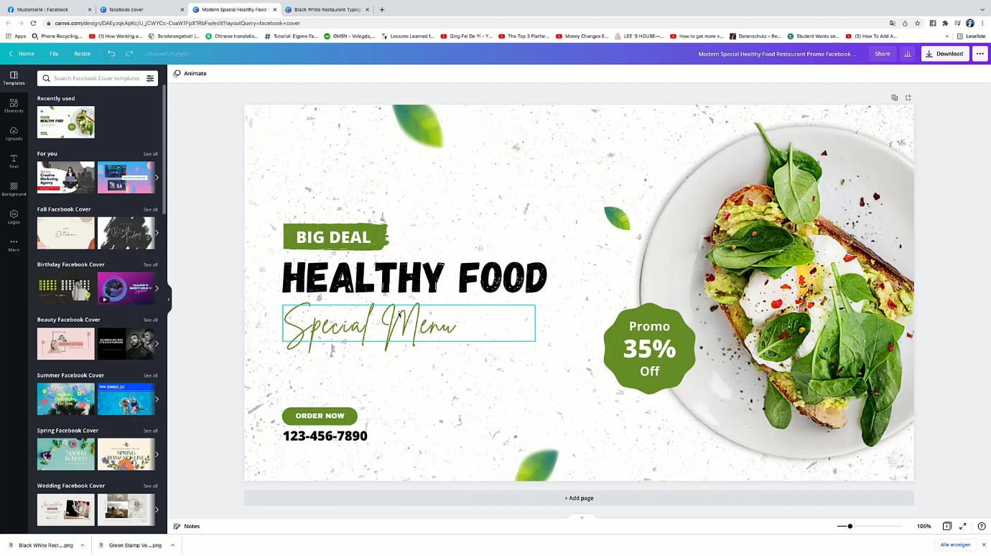
- Keep design simple and readable

4. YouTube Thumbnails & Channel Art in Canva
YouTube Thumbnails
- Help attract viewers to videos
- Standard size: 1280 × 720 pixels
Design Tips:
- Use bold text
- High contrast colors
- Close-up faces get more attention
- Keep text short (3–5 words)
YouTube Channel Art
- Displays branding on the channel page
- Standard size: 2560 × 1440 pixels
Important:
- Keep important text in the safe area
- Maintain consistent branding

5. LinkedIn Posts & Banners in Canva
LinkedIn Posts
- Used for professional content
- Standard size: 1080 × 1080 pixels
Design Style:
- Clean and professional
- Simple fonts
- Soft colors
LinkedIn Banners
- Used as profile or company cover image
- Standard size: 1584 × 396 pixels
Tips:
- Include professional tagline
- Avoid clutter
- Use minimal text

Assignment: Clean Environment Social Media Post

Steps to Create in Canva:
- Start a New Design: From the Canva dashboard, select "Social Media" or specifically "Instagram Post" for a square format.
- Search for Templates (Optional but Recommended): In the search bar, type "environment," "clean up," "nature," or "sustainability" to find relevant templates. You can also start from scratch.
- Choose a Background/Image:
  - Photos: Go to the "Photos" tab and search for images like "clean beach," "green forest," "people cleaning," or "environmental protection." Select one that visually represents a clean environment.
  - Elements: If you want a more graphic look, go to "Elements" and search for nature-related graphics (trees, leaves, water droplets) or symbols of cleanliness.
- Add Your Message:
  - Go to the "Text" tab and add a heading and a body of text.
  - Heading Idea: "Keep Our Planet Green!" or "Clean Earth, Happy Future."
  - Body Text Idea: "Every small action counts. Let's work together to protect our environment and ensure a beautiful world for generations to come. #CleanEnvironment #GoGreen"
- Customize Fonts and Colors: Choose fonts that are easy to read and colors that reflect nature (greens, blues, browns) or cleanliness (whites, light blues).

