Branding & Visual Identity Using Canva

1. Introduction to Branding & Visual Identity
Branding is the process of creating a unique identity for a business or organization. Visual identity includes all the visual elements such as colors, fonts, logos, and layouts that represent the brand. Canva helps in creating and maintaining a consistent brand easily.

2. Creating a Brand Kit in Canva (Colors, Fonts, Logos)
A Brand Kit in Canva stores all brand elements in one place.
Brand Colors
- Colors represent the brand’s personality
- Canva allows saving primary, secondary, and accent colors
- These colors can be used in all designs
Brand Fonts
- Fonts give a professional and consistent look
- Canva allows saving:
  - Heading font
  - Subheading font
  - Body text font
Brand Logos
- Logos are the visual symbol of a brand
- Canva allows uploading and saving multiple logo versions
- Logos can be reused in any design
Benefits of Brand Kit:
- Saves time
- Maintains consistency
- Easy access to brand assets

3. Using Brand Templates
Brand templates are pre-designed layouts that follow brand rules.
Features:
- Fixed colors and fonts
- Reusable layouts for social media, presentations, and documents
How to Use:
- Open Canva
- Select a brand template
- Edit text or images
- Keep brand elements unchanged
Advantages:
- Uniform designs
- Faster content creation
- Professional appearance

4. Designing Logos in Canva
Canva provides easy tools for logo design.
Steps to Design a Logo:
- Open Canva
- Select Logo
- Choose a template or blank design
- Add brand name and icon
- Select brand colors and fonts
- Adjust size and alignment
- Download logo
Logo Design Tips:
- Keep it simple
- Use minimal colors
- Ensure readability
- Avoid too many fonts

5. Creating Brand Style Guides
A Brand Style Guide explains how brand elements should be used.
Contents of a Style Guide:
- Logo usage rules
- Color codes (HEX, RGB)
- Font styles and sizes
- Image and icon style
- Tone of communication
Purpose:
- Maintains consistency
- Helps designers and team members
- Ensures correct brand representation
Canva allows creating and sharing brand style guides easily.

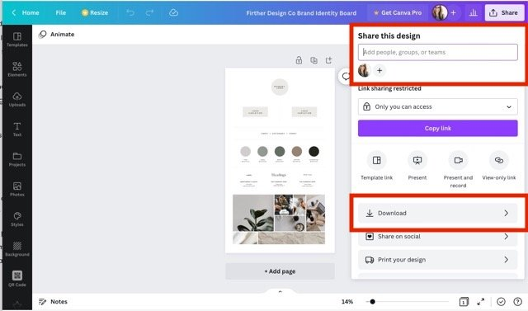
6. Maintaining Consistent Branding
Consistency helps in building trust and brand recognition.
Best Practices:
- Use the same logo everywhere
- Apply brand colors and fonts consistently
- Follow brand templates
- Keep design style uniform
- Avoid frequent changes
Role of Canva:
- Brand Kit ensures uniformity
- Templates reduce design errors
- Easy collaboration with teams

Assignment: Creating a Brand Kit for a Chocolate Company in Canva

Steps to Create a Chocolate Company Brand Kit:
- Define Your Brand Identity: Decide if your chocolate brand is luxury, organic, or fun. This will guide your design choices.
- Select a Color Palette: * Choose "chocolatey" colors like deep browns, caramels, or gold for luxury.
- Choose Your Fonts: * Pick a "Heading" font and a "Body" font that are clean and professional.
- Create or Upload a Logo: * Use the Search Bar on the dashboard to find "Chocolate Logo" templates.
  - Customize the template with your company name and chosen colors.
  - Drag and drop the finished logo into your Brand Hub for easy access later.
- Add Brand Elements: * Search the Elements tab for icons like cocoa beans or chocolate bars to use as standard graphics across your designs.
- Apply to Designs: * Now, when you create a new Instagram post or Menu, your saved colors and logos will be ready to use in the sidebar, ensuring every post looks like it belongs to your brand
