Canva for Marketing

1. Introduction to Canva for Marketing
Canva is widely used for marketing because it allows users to create attractive promotional materials easily. Marketers can design posters, flyers, brochures, ads, and catalogs without professional design skills.

2. Designing Posters & Flyers
Posters
- Used for promotions, events, and announcements
- Usually large and visually attractive
Flyers
- Used for advertising products, services, or events
- Smaller and easy to distribute
Steps in Canva:
- Open Canva
- Select Poster or Flyer
- Choose a template
- Edit text, images, colors, and fonts
- Download or print
Design Tips:
- Use bold headlines
- Keep content short
- Use high-quality images
- Add contact details clearly

3. Creating Brochures & Business Cards
Brochures
- Provide detailed information about a business or product
- Can be bi-fold or tri-fold
Steps:
- Select Brochure in Canva
- Choose a layout
- Add text, images, and icons
- Maintain brand colors and fonts
Business Cards
- Used for professional identity
- Contains name, logo, contact details
Standard Size:
- 3.5 × 2 inches
Tips:
- Simple design
- Clear text
- Use brand logo and colors
4. Designing Email Headers & Newsletters
Email Headers
- Top image in an email
- Used for branding and promotion
Design Tips:
- Keep width suitable for email
- Use minimal text
- Include logo and tagline
Newsletters
- Used to share updates, offers, and information
Steps:
- Choose Newsletter template
- Add images and text blocks
- Use clear headings
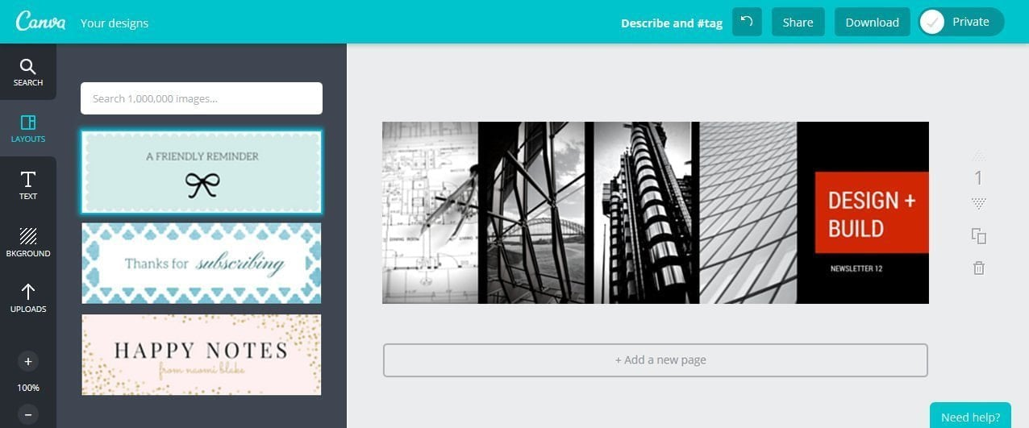
- Maintain readability

5. Custom Designs for Ads
Canva helps create ads for:
- Social media
- Websites
- Online campaigns
Ad Design Tips:
- Clear message
- Strong call-to-action (CTA)
- Eye-catching visuals
- Minimal text
Steps:
- Select Custom Size or Ad template
- Design according to platform
- Use brand elements
- Download in required format

6. Creating Product Catalogs
Product catalogs display product details and images.
Uses:
- Online marketing
- Print distribution
- Sales presentations
Steps:
- Choose Catalog template
- Add product images
- Include product name, price, and description
- Use consistent layout
- Download as PDF
Tips:
- High-quality images
- Clear product information
- Consistent spacing and alignment

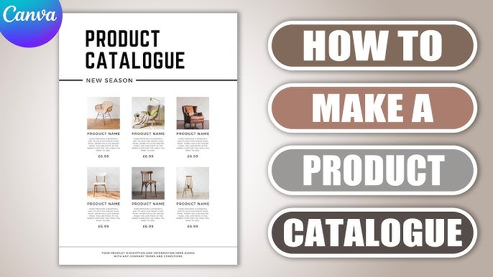

7. Benefits of Using Canva for Marketing
- Easy drag-and-drop tool
- Ready-made marketing templates
- Professional designs
- Saves time and cost
- Suitable for beginners and professionals

Assignment – Trifold Brochure on “Really Good School”

1. Select the Trifold Brochure Format
- Access the Dashboard: Log in to your Canva account to reach the Canva Dashboard.
- Search for a Template: Use the Search Bar at the top of the dashboard and type "trifold brochure".
- Pick a Specific Style: Select a template that fits your needs, such as a "Modern Professional School Profile Trifold Brochure".

2. Customize the Layout and Content
- Edit Text: Double-click on any existing text box to replace the placeholder content with your own, such as "Building Knowledge, Building Character" or "School Facilities".
- Change Fonts: Select your text and use the font menu to choose clean, professional styles.
- Adjust Colors: Click on background elements or text to change them to your preferred color palette.
- Drag-and-Drop Photos: Use the Uploads tab to bring in your own images, then simply drag and drop them into the existing photo frames on the template.

