Introduction to Google Ads

What are Google Ads (AdWords)?
Google Ads (formerly called Google AdWords) is an online advertising platform created by Google.
It allows businesses to show their ads on:
- Google Search
- YouTube
- Websites
- Mobile apps
- Google Maps
- Shopping section
In simple terms:
Google Ads = You pay Google → Your ad appears to people searching for products/services like yours.

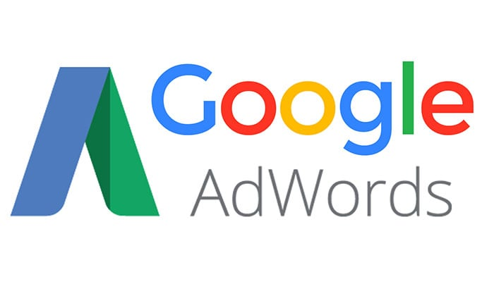

Why is it called “Ads”?
Because you run advertisements (ads) that appear to users when they search something related to your business.
Previously it was called Google AdWords, because ads used to be based mainly on words (keywords).
Now it includes images, videos, shopping ads etc., so the name was changed to Google Ads.

How Google Ads Works?
- You choose keywords
Example: A bakery chooses
👉 “cake delivery near me”
👉 “birthday cakes in Mumbai”
- You create your ad/post/design/template
Example:
“Fresh Birthday Cakes – Order Online, Fast Delivery in Mumbai!”
- When someone searches the keyword…
Google shows your ad at the top of search results.
- You pay only when someone clicks your ad.
This system is called PPC (Pay Per Click).

Real-Life Examples of Google Ads
Example 1: Searching on Google
You type:
Try: “Buy running shoes online”
The first results with Ad written on them are Google Ads from:
- Amazon
- Myntra
- Ajio
They are paying Google to show their website first.

Example 2: A Local Business
A café in Pune runs ads for:
Try: “coffee shop near me”
Now anyone nearby searching for coffee sees their ad at the top.
They get:
✔ more customers
✔ more foot traffic
✔ more orders

Example 3: YouTube Ads
Before a video, you see:
👉 “Download the Lenskart App!”
👉 “Try Zomato Gold Today!”
These are also Google Ads (because YouTube = owned by Google).

Example 4: Shopping Ads
Search:
Try: “buy smartphone online”
You see phone pictures, prices, stores — these are Google Shopping Ads.
Brands pay Google to appear here.

Why Do Businesses Use Google Ads?
Because Google is the most used search engine in the world.
Google Ads helps businesses:
✔ Reach the right customers
✔ Get instant visibility
✔ Increase sales quickly
✔ Compete with big brands

Now: Creating a Google Account to Use Google Ads
To run Google Ads, the first step is to create a Google Account.
Good news:
If you already have a Gmail account, you already have a Google account.
You can directly use Google Ads.
If not, here is the step-by-step guide:

How to Create a Google Account:
Step 1: Visit the Google Account Sign-up Page
Go to:
accounts.google.com/signup
Step 2: Fill in Basic Details
You will be asked to enter:
- First Name
- Last Name
- New Gmail address (choose one)
- Password (twice for confirmation)
Step 3: Enter Your Phone Number
Google will send a code (OTP).
Enter it to verify your phone.
This keeps your account safe.
Step 4: Add Recovery Information
You may add:
- A recovery email (optional)
- Date of birth
- Gender
Step 5: Accept Terms
Google will show privacy terms.
Click “I Agree”.
Your Google Account is created!

How to Access Google Ads After Creating a Google Account
Step 1: Go to Google Ads
Visit:
👉 ads.google.com
Step 2: Sign In
Use your new Google/Gmail account.
Step 3: Start Setting Up
Google will ask:
- Your business name
- Your website
- Your location
- Your campaign goals (sales, leads, website visits, etc.)
Step 4: Begin Creating Ads
You can now create:
- Search ads
- Display ads
- Video ads
- Shopping ads
- App install ads
You don’t have to run an ad immediately — you can explore everything for free.

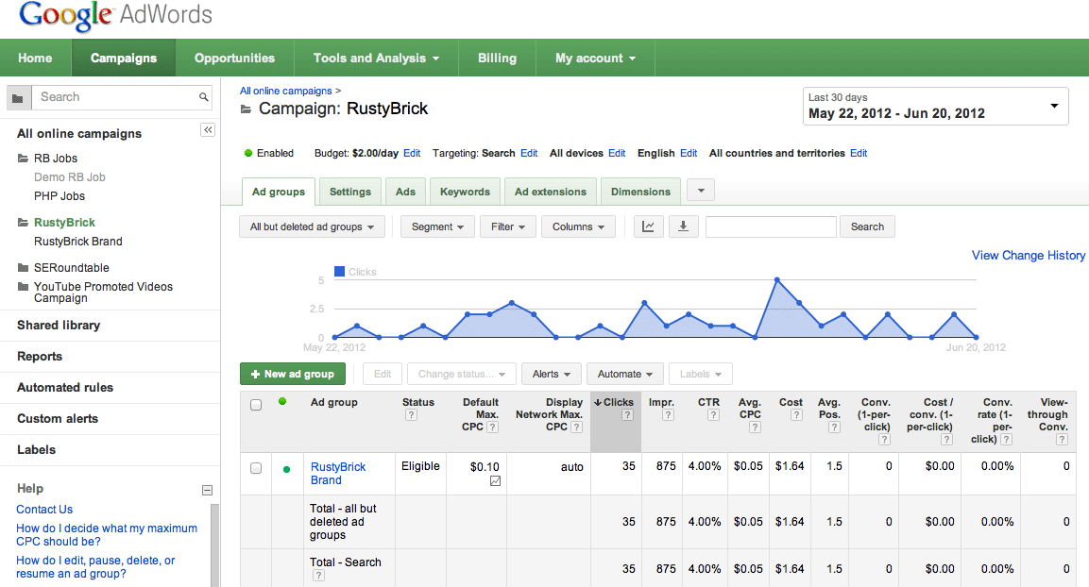

Real-Life Example: Using Google Account for Google Ads
Example: SweetTreats Bakery (Mumbai)
- They created a Gmail account:
👉 sweettreats.bakery@gmail.com
- Logged into ads.google.com
- Created ads for keywords like:
👉 “cake delivery Mumbai”
👉 “birthday cakes near me”
- People searching these terms saw the bakery ad.
- Customers clicked → placed orders → bakery got sales.
All because they created a simple Google Account and used Google Ads.

Assignment
Ques 1: What was Google Ads formerly called?
A) Google WebWords
B) Google AdWords
C) Google SearchPlus
D) Google Business

Ques 2: In the PPC (Pay Per Click) system, when does a business pay Google?
A) When they first create the account
B) Every time the ad is shown on the screen
C) Only when someone clicks on their ad
D) Only at the end of the year

Ques 3: Which of the following platforms are owned by Google and show Google Ads?
A) YouTube and Google Maps
B) Instagram and Facebook
C) WhatsApp and Netflix
D) Twitter and LinkedIn

Ques 4: If you already have a Gmail account, what do you need to do to start using Google Ads?
A) Create a brand new identity
B) You can directly use Google Ads with your Gmail account
C) Pay a $100 entry fee
D) Wait for 6 months for approval

Ques 5: Why did Google change the name from "AdWords" to "Google Ads"?
A) Because the old name was too long
B) Because ads now include images, videos, and shopping, not just words
C) Because they wanted to start charging more money
D) Because the word "AdWords" was trademarked by another company

