Microsoft Word

Module 32 - Working with Symbols in MS Word

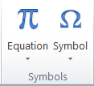
Using the Symbol Group with Equations

In MS Word, the Symbol Group is a part of the Insert tab that allows users to insert special characters, mathematical symbols, and other non-standard text elements into a document.

Features of the Symbol Group:
- Symbol Button – Opens a list of commonly used symbols like ©, ®, €, ¥, etc.
- More Symbols – Opens a dialog box where you can find and insert a wide range of symbols.
- Equation Button – Allows users to insert and edit mathematical equations.
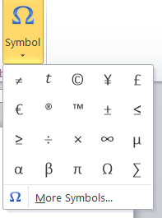
- Equation Editor – Provides a tool to create complex mathematical expressions using various operators and symbols.

Symbols in MS Word
In MS Word, Symbols are special characters, mathematical signs, currency symbols, and other non-standard text elements that are not available on a standard keyboard. These symbols help users insert scientific notations, equations, and special characters into their documents.

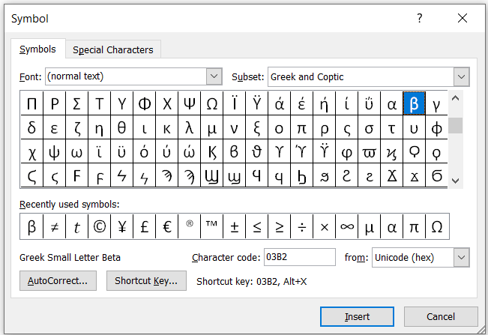
More Symbols in MS Word
In MS Word, the "More Symbols" option allows users to insert a wide variety of special characters, mathematical symbols, currency symbols, and other non-standard text elements that are not available on a regular keyboard.

Symbol Shortcuts in MS Word
In MS Word, symbol shortcuts allow users to quickly insert special characters and symbols using keyboard shortcuts instead of manually selecting them from the Symbols menu.
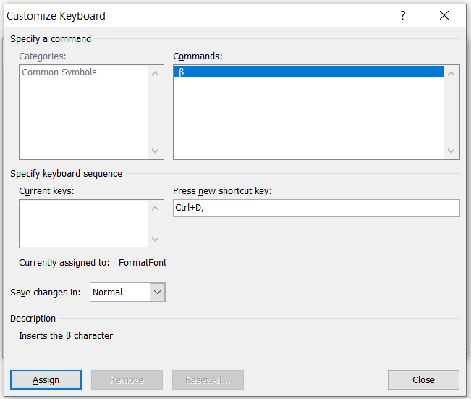
Custom Shortcut
A custom shortcut in MS Word is a user-defined keyboard shortcut that allows you to insert symbols, execute commands, or format text quickly. If a symbol or command does not have a default shortcut, you can assign your own shortcut key for faster access.

Auto Correct
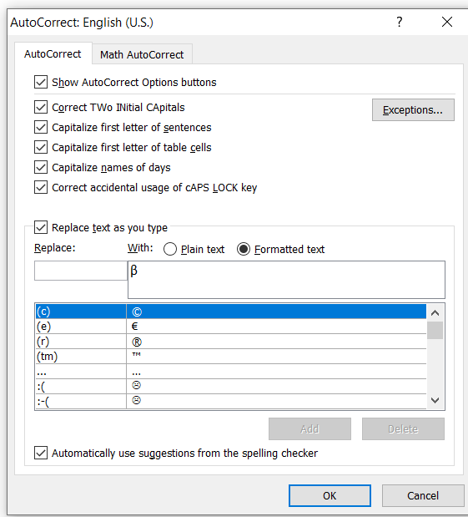
AutoCorrect in MS Word automatically replaces specific text shortcuts with symbols or special characters. This feature helps users quickly insert commonly used symbols without manually searching for them.
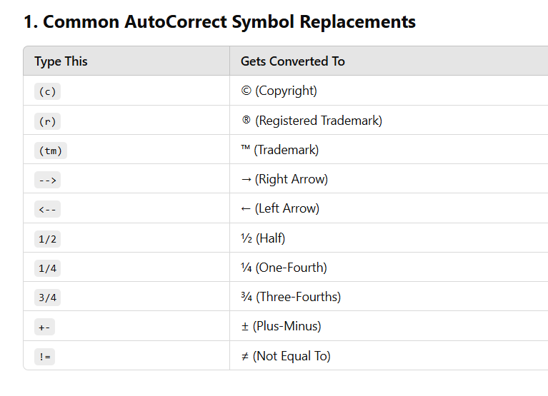

Special Character in MS Word
A special character is a symbol, punctuation mark, or other text element that is not found on a standard keyboard. These characters are used for formatting, mathematical expressions, and various text enhancements in MS Word.

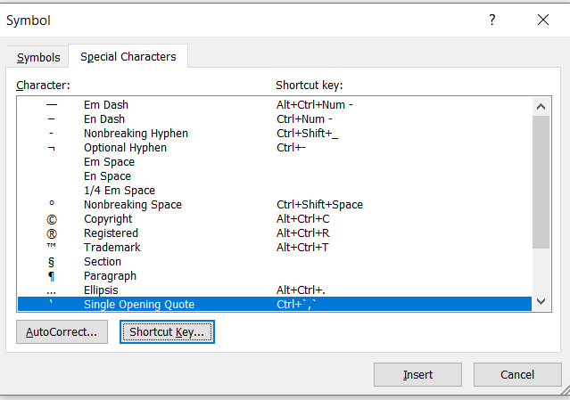

Finding the More Symbols:
You need to change the font in the Symbol dialog:

- Go to the Insert tab on the top ribbon.
- Click on Symbol in the Symbols group.
- Select More Symbols... from the dropdown menu to open the full dialog box.
- Font: Select Wingdings 2 from the dropdown list.
- Search: Scroll through the grid to find The More symbols like(Cross, Star checkbox, clock etc)
- Insert: Click on the symbol you want and then click the Insert button.

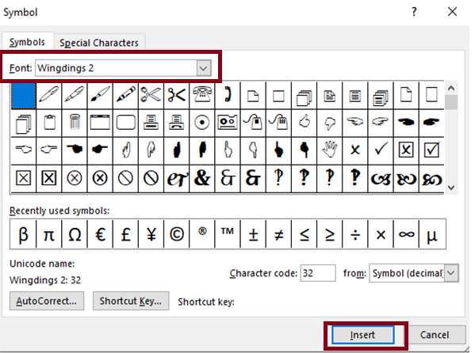

Why we use Symbols in MS Word?
Symbols in MS Word are used to insert special characters, mathematical signs, and foreign language letters that aren't available on a standard keyboard. They enhance document formatting, clarity, and accessibility.

Assignment

Write this Following Paragraph in MS Word
Online ##education has revolutionized the way we learn, making knowledge accessible anywhere, anytime. With platforms offering @-home learning, students can #stayconnected with teachers & peers across the globe. (The convenience of digital tools enables efficient communication, interactive lessons, )and access to resources, empowering learners to achieve success in their academic journey.

Online education has transformed the traditional learning experience, offering flexibility and accessibility like never before. Students can engage with interactive content, attend virtual classrooms, and collaborate with classmates, all from the comfort of their homes. With a simple click, learners can access a wealth of knowledge, from % math equations to ^ advanced science concepts. This digital shift ensures that education is no longer limited by geography or time, allowing everyone to #learnanywhere and #succeedanytime.

