Introduction to Social Media Marketing

Social media has become one of the most effective and popular ways of communication in today’s digital world. The use of social media is increasing very fast. As of April 2023, there are around 4.8 billion social media users worldwide, which is nearly 59.9% of the world’s total population.

China has the highest number of social media users, followed by India and the United States. Social media refers to different online platforms and applications that allow people to create, share, and interact with content such as text, images, videos, and messages.

These platforms help people communicate, share information, and connect with others across the internet. Today, social media has become an important part of daily life. It has greatly changed the way people talk to each other, get news, and share their ideas, opinions, and experiences with others.

Comparison of Social Media Marketing with Other Marketing Methods
Social media marketing is different from traditional marketing methods in many ways. Each type of marketing has its own benefits and limitations. Below is a simple comparison between social media marketing and traditional marketing.

1. Reach and Target Audience
Social Media Marketing:
Social media platforms have billions of users. Businesses can easily target specific people based on age, location, interests, and behavior, which helps in reaching the right audience.
Traditional Marketing:
Methods like TV, radio, and newspapers can reach many people, but it is difficult to target a specific group accurately.

2. Cost-Effectiveness
Social Media Marketing:
Social media marketing is usually low-cost and suitable for small businesses. Advertisers can control their budget and pay only for results.
Traditional Marketing:
Advertising on TV or radio is expensive and not affordable for many small businesses.

3. Engagement and Interaction
Social Media Marketing:
Social media allows two-way communication. Customers can like, comment, share, and message brands directly.
Traditional Marketing:
Traditional marketing is mostly one-way communication, where businesses send messages but do not get instant responses from customers.

4. Feedback and Analytics
Social Media Marketing:
Businesses can get instant feedback and detailed data such as views, likes, clicks, and sales.
Traditional Marketing:
Feedback is slow and limited, making it hard to measure the success of ads quickly.

5. Content and Creativity
Social Media Marketing:
Different content types like images, videos, reels, stories, and live videos can be used, allowing more creativity.
Traditional Marketing:
Content options are limited to TV ads, radio ads, and print advertisements.

Social Media Competitors
Social media competitors are other platforms or companies that target the same users and want to gain a larger share of the social media market. These platforms compete with each other to attract users by offering different features, better user experience, and new types of content.

Competition in social media is very strong because every platform wants users to spend more time, stay active, and share more content on their platform. To stand out, each social media platform focuses on its own special features, purpose, and type of users. This helps them remain different from other competing platforms.

TikTok vs Instagram vs Snapchat vs YouTube
TikTok became very popular because it focused on short videos, usually with music or audio. Its special algorithm shows users videos they are likely to enjoy, which keeps people watching for a long time. TikTok grew very fast, especially among young users, and became a major trend on social media.

Instagram, which is owned by Facebook (Meta), introduced Instagram Reels after TikTok became successful. Reels allows users to make and share short videos similar to TikTok. By adding Reels inside the Instagram app, Instagram tried to keep its users from moving to TikTok.

Snapchat is known for disappearing photos and videos and fun filters. It also introduced Stories and augmented reality (AR) features. However, Snapchat faced strong competition when Instagram and TikTok launched similar features, which affected its growth in some areas.
YouTube was earlier mainly used for long videos. Seeing the popularity of short videos on TikTok, YouTube launched YouTube Shorts. This feature allows users to create and watch short videos, helping YouTube compete with TikTok.
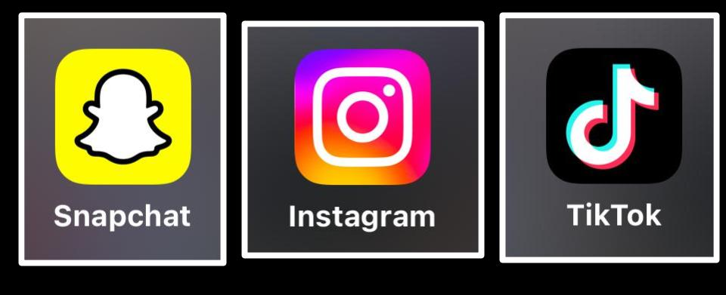

Conclusion
TikTok’s success with short videos forced other platforms like Instagram, Snapchat, and YouTube to add similar features. This competition encourages innovation and helps social media platforms improve continuously to meet users’ changing needs.

Strategy Planning and Social Media Marketing
As a social media marketer, the main goal is to grow a business using social media platforms. Social media keeps changing every day, so new ideas and strategies must be used regularly. If a business does not update its social media strategy, it may fall behind competitors and lose customers.
Below are the important steps to follow before creating a social media marketing strategy:

1. Audit Your Current Social Media Position
The first step is to understand where your business currently stands on social media.
- How many followers do you have?
- How much engagement (likes, comments, shares)?
- What are your strengths and weaknesses?
- How are competitors performing?

Real-life Example:
A coaching institute checks its Instagram page and finds that posts get likes but very few inquiries. This shows good reach but weak conversion.

2. Identify Your Target (Prospective) Customers
Next, find out who your ideal customers are.
This can be done using different types of segmentation such as:
- Demographic (age, gender, location)
- Behavioral (buying habits)
- Lifestyle (student, working professional)
Real-life Example:
An IELTS coaching center targets students aged 18–25 who are interested in studying abroad.

3. Create a Social Media Mission Statement
A mission statement clearly defines:
- Why you are on social media
- What kind of content you will share
Quote:
"What makes you different makes you stand out."
Real-life Example:
A digital marketing institute’s mission:
“To educate beginners about digital marketing through easy Instagram posts and videos.”
This helps decide what type of content to post.

4. Set Success Benchmarks (Goals)
Benchmarks help measure success and performance.
Common benchmarks include:
- Reach
- Likes and shares
- Website visits
- Leads and sales
Real-life Example:
Goal: Get 100 leads from Facebook ads in one month.

5. Create Attractive Content
Content should be interesting, useful, and eye-catching so people stop scrolling and engage.
Types of content:
- Blogs
- Reels and videos
- Influencer posts
- Infographics
- Viral and buzz content
Real-life Example:
A food brand posts short cooking reels that go viral and increase orders.

Simple comparison between different social media platforms:

Platform | Main Purpose | Content Type | Audience Type | Best For
Facebook | Social networking | Text, photos, videos, groups | General public | Community building, ads
Instagram | Visual sharing | Photos, Reels, Stories | Youth & young adults | Brand promotion, influencers
Twitter (X) | Short updates & news | Short text, threads, news | Professionals & news followers | Real-time updates, discussions
LinkedIn | Professional networking | Career posts, articles | Professionals & businesses | Jobs, B2B marketing
YouTube | Video sharing | Long & short videos | All age groups | Tutorials, entertainment
WhatsApp | Messaging | Text, voice, video, status | Personal & business users | Communication, customer support

Assignment

Business Idea 1: 10th Class Tuition
- Who is the primary target audience for this business?
a) College students
b) 10th class students
c) Working professionals
d) Toddlers
- What is the main need this business fulfills?
a) Entertainment
b) Education and exam preparation
c) Sports training
d) Travel guidance
- Which marketing platform is most suitable for reaching potential customers?
a) LinkedIn
b) Instagram
c) School notice boards and WhatsApp groups
d) YouTube cooking channels
- What is the best way to offer value to students?
a) Provide high-quality tuition and study materials
b) Give free shoes
c) Offer free movie tickets
d) Sell snacks in the classroom
Business Idea 2: Factory-Made Shoes
- Who are the potential customers for this business?
a) Students and working adults needing footwear
b) Only doctors
c) Farmers only
d) Babies under 1 year
- Which factor is most important for marketing shoes?
a) Price, quality, and style
b) Tuition classes
c) Exam preparation
d) Music taste
- Which marketing platform is most effective for this business?
a) Instagram and Facebook ads
b) School tuition WhatsApp groups
c) LinkedIn articles
d) Twitter threads on exams
- What is a competitive advantage for factory-made shoes?
a) Unique design and durability at a good price
b) Offering tuition for students
c) Selling snacks online
d) Free music downloads

