Facebook Marketing

Facebook marketing means using Facebook to promote a business or brand. It helps companies become more well-known, gain more followers, collect customer leads, and sell products or services. Businesses use Facebook Pages to share information, advertise, and even sell directly to customers. A Facebook Page can work like a second website for a company.
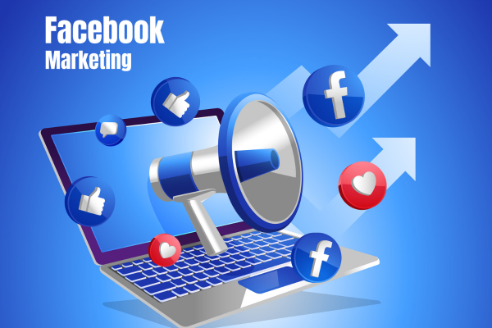

Here are some key features and steps for effective social networking on Facebook:
1. Create an Account:
o Visit the Facebook sign-up page and create a new account by providing your
details.
o Set up your profile picture, cover photo, and add relevant information about
yourself.
2. Connect with Friends and Family:
o Search for friends using their names or email addresses.
o Send friend requests to connect with people you know.
o Accept friend requests from others who want to connect with you.
3. News Feed:
o The News Feed is where you’ll see updates from your friends, pages you follow,
and groups you’re part of.
o Interact with posts by liking, commenting, or sharing them.
4. Messenger:
o Use Facebook Messenger to chat with friends privately.
o You can send text messages, voice messages, and even make video calls.
5. Timeline and Wall:
o Your Timeline is your personal profile page where you can share your own
content.
o The Wall is where your friends can post messages, photos, and videos on your
profile.
6. Events:
o Check out Events to see upcoming birthdays, parties, gatherings, and other social
events.
o You can create your own events and invite friends.
7. Groups and Pages:
o Join Groups related to your interests (e.g., hobbies, communities, fan clubs).
o Follow Pages of brands, celebrities, or organizations to stay updated.
8. Privacy Settings:
o Customize your privacy settings to control who can see your posts, photos, and
personal information.
o Decide who can send you friend requests and who can see your friend list.
9. Explore Features:
o Facebook offers various features like live streaming, photo albums, reactions
(like, love, etc.), and more.
o Stay informed about new features and updates by exploring the platform
regularly.

Facebook Basics
Facebook is a popular social media platform that allows people to connect, share content, and communicate online. Some basic features of Facebook are:
- Profile: When you join Facebook, you create a profile. It includes your name, profile picture, cover photo, and other personal details you choose to share.
- News Feed: The News Feed is the main screen on Facebook. It shows posts from your friends and the pages you follow. You can like, comment on, and share these posts.
- Pages: Facebook Pages are used by businesses, organizations, and public figures. People can follow these pages to get updates and news.
- Privacy: Facebook gives you privacy settings to control who can see your posts, send you friend requests, or find you using your phone number or email.
- Timeline: Your timeline shows all your posts, photos, and activities in order from newest to oldest. You can choose who is allowed to see it.
- Notifications: Facebook sends notifications when someone likes your post, comments, sends a message, or invites you to an event. You can control these alerts in settings.
- Ads: Facebook shows ads based on your interests and online activity. You can manage ad preferences and hide ads you don’t like.
- Messenger: Facebook Messenger lets you send private messages, photos, videos, and make voice or video calls.
- Safety and Security: Stay safe by using strong passwords, turning on two-factor authentication, and being careful about what you share online.
- Marketplace: Facebook Marketplace allows people to buy and sell items locally.
- Events: Facebook Events help you create events, invite people, and track who is attending.

Facebook Pages
A Facebook Page is the foundation of Facebook marketing. Businesses, brands, and organizations use Pages (not personal profiles) to promote themselves.
Why Facebook Pages are important:
- They act like a mini website on Facebook
- People can follow or like the page
- Businesses can post updates, offers, photos, videos, and announcements
- Customers can review, comment, and message the business
A well-managed page helps build brand identity, trust, and customer engagement.

Steps to Create a Facebook Page
A Facebook Page is used for businesses, brands, organizations, or public figures.
Step 1: Log in to Facebook
Log in using your personal Facebook account.
Step 2: Create a Page
- Click Menu (☰) → Pages
- Click Create New Page
Step 3: Enter Page Details
- Page Name (Business or brand name)
- Category (e.g., Business, Education, Marketing)
- Description (short info about the page)
Step 4: Add Profile & Cover Photo
- Profile photo: Logo or brand image
- Cover photo: Banner showing services, offers, or brand message
Step 5: Complete Page Information
- Add contact details, website link, location, and working hours
- Set a call-to-action button (Like “Contact Us”, “Shop Now”)
Step 6: Start Posting Content
Post images, videos, offers, and updates to engage followers.

Facebook Ads
Facebook Ads are paid promotions that allow businesses to reach a targeted audience.
Key features of Facebook Ads:
- Advertisers can target users based on age, gender, location, interests, behavior, and profession
- Ads can appear in the News Feed, Stories, Marketplace, and Messenger
- Different ad formats are available, such as image ads, video ads, carousel ads, and lead ads
Benefits:
- Reaches the right audience
- Increases website traffic and sales
- Helps generate leads quickly
For digital marketers, Facebook Ads are powerful because they are cost-effective and measurable.
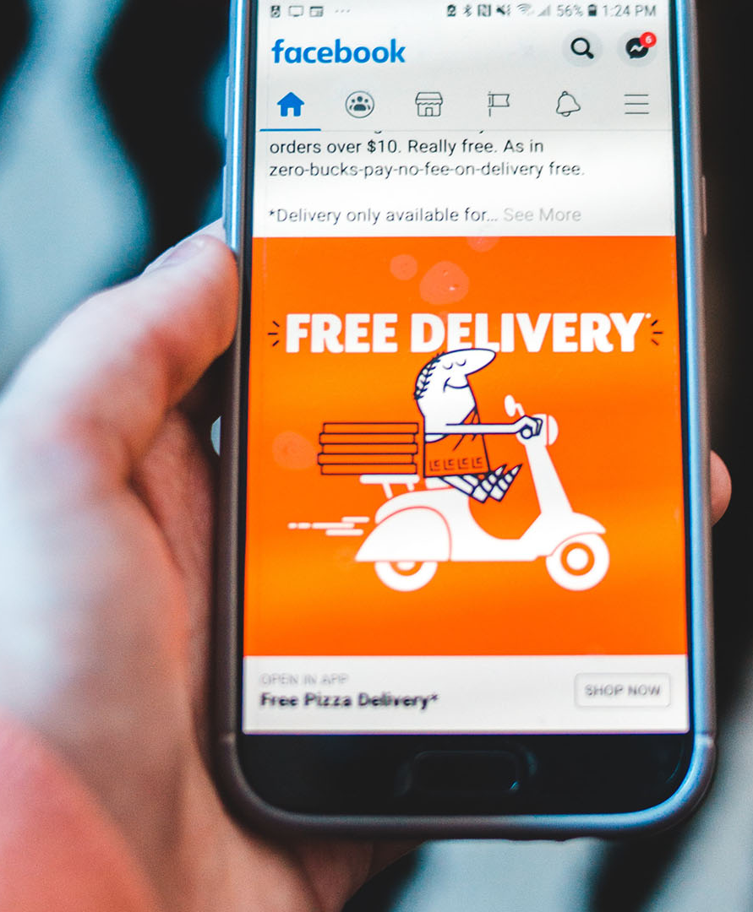

3. Content Creation & Engagement
Content is what businesses post on their Facebook Page. This includes:
- Text posts
- Images and infographics
- Videos and reels
- Polls and stories
Good content helps to:
- Attract attention
- Encourage likes, shares, and comments
- Build relationships with followers
Engagement (likes, comments, shares, messages) shows how interested users are in the brand. Higher engagement improves visibility and trust.

Assignment: Create a Facebook Ad for "Sweet Bites Bakery"

Step 1: The Plan (The Strategy)
Before we make the ad, we need to know who we are talking to.
- Who is the customer? People living in your city who have a birthday coming up or love sweets.
- What is the goal? To get people to message the bakery on WhatsApp or Messenger to order a cake.

Step 2: Designing the Ad (The Creative)
A good Facebook ad has three simple parts: The Text, The Image, and the Button.
1. The Text (What you say):
"Stop buying boring cakes! 🎂 Get a custom-made, delicious cake for your special day. From chocolate truffle to fruit blast, we bake it fresh just for you. Order now and get free delivery!"
2. The Image (What they see):
- Idea: A bright, yummy photo of a half-cut chocolate cake with melting cream. (People stop scrolling when they see tasty food!)
3. The Button (What they do):
- Action: [Send Message]

Step 3: Setting the "Target" (The Logic)
In your digital marketing class, you need to show how you will find the right people. Tell your teacher you will pick these settings on Facebook:
- Location: Only people living within 10km of the bakery. (No point showing the ad to someone 500km away!)
- Interests: People who like "Cakes," "Birthday Parties," or "Desserts."
- Timing: Run the ad on Thursdays and Fridays (when people are planning for the weekend).

3 Simple Rules for your Assignment:
- Use Emojis: They make the ad look friendly and less like a "boring business."
- Short Sentences: Nobody reads long paragraphs on Facebook.
- Clear Offer: Tell them exactly what they get (e.g., "Free Delivery").

Assignment

Local Gym – Lead Generation
Q1. What targeting is best for a local gym?
A) Worldwide
B) Entire country
C) 3–8 km radius around gym
D) Only online interests

Q2. Best age group for a general fitness gym?
A) 13–17
B) 18–45
C) 45–65 only
D) 60+

Q3. Which offer increases conversions most?
A) Free PDF
B) 7-Day Free Trial
C) Blog Link
D) Awareness Video

Q4. Best retargeting audience?
A) Everyone in city
B) Page followers
C) People who opened lead form but didn’t submit
D) Random interests

Real Estate – Luxury Villas
Q1. Best way to qualify high-budget buyers?
A) Short form
B) Long form with budget question
C) No form
D) Engagement ad

Q2. Ideal targeting for luxury homes?
A) Students
B) Low income
C) High income interests & business owners
D) Teenagers

Q3. Best ad creative?
A) Meme
B) Carousel showcasing property
C) Text-only ad
D) Random stock image

Q4. Best campaign structure?
A) Single ad only
B) Awareness only
C) Lead Gen + Retarget Website Visitors
D) Traffic only

