YouTube Marketing

YouTube is the most popular video-sharing website in the world. Businesses can create their own channel, upload videos, make playlists, reply to comments, and connect with their audience. Since Google bought YouTube in 2006, YouTube videos often appear at the top of Google search results. This makes it a powerful marketing tool.

YouTube Basics
1. Creating an Account
To use YouTube, you need a Google account.
You can log in with your Gmail account. If you don’t have one, you can create a Google account for free.
2. Uploading Videos
- Log in to YouTube.
- Click the Upload button (camera icon) at the top right.
- Choose a video file from your computer.
- Add a title, description, and select your settings.
3. Video Privacy Settings
When uploading, choose who can see your video:
- Public – Anyone can watch it.
- Private – Only you can see it.
- Unlisted – Only people with the link can watch it.

4. Engage with Your Audience
YouTube is a social platform, so interaction is important.
- Reply to comments.
- Ask for feedback.
- Build a strong community around your channel.

5. Monetization
If you meet YouTube’s rules, you can earn money through:
- Ads
- Channel memberships
- Selling merchandise
This helps you make income from your videos.

6. Copyright & Fair Use
- Do not use music, images, or videos without permission.
- Make sure you have the right to use any content in your video.

7. Analytics
YouTube gives you data about:
- Views
- Watch time
- Audience behavior
Use this information to improve your content.

8. Community Guidelines
Follow YouTube’s rules.
Breaking the rules can lead to warnings, loss of money (demonetization), or even channel removal.

9. YouTube Studio
Use YouTube Studio to:
- Manage videos
- Reply to comments
- Check analytics
It is the main tool for creators.

10. SEO Best Practices
- Use the right keywords in your title and description.
- Add tags and captions.
- This helps your videos rank higher in YouTube and Google search results.
These basics will help you start and grow your YouTube channel easily.

Advertising on YouTube
Advertising on YouTube is a great way to reach a large audience. Businesses can choose different ad types based on their goals and budget.
To succeed, create interesting and relevant ads that attract your target audience. It is also important to understand YouTube’s advertising rules and best practices before starting.

Here are some common YouTube ad options:
1. Display Ads
These are regular ads that appear:
- On the YouTube homepage
- Next to videos
- Above the suggested video list
They can be text, image, or rich media ads.
2. Sponsored Cards
These are small ads that appear inside videos.
- They give more information about a product or service.
- They often include a call-to-action like “Learn More” or “Buy Now.”

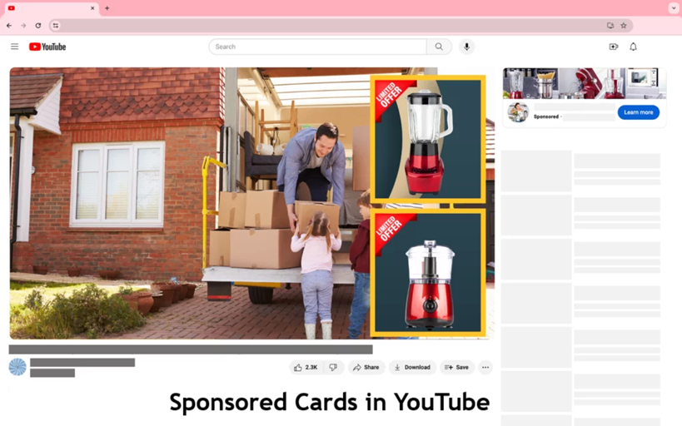

3. Shopping Ads
These ads show products directly inside videos.
- Viewers can click on the product image.
- They can learn more or buy the product easily.
4. Channel Memberships
This feature allows viewers to pay a monthly fee to support a creator.
- Members get special benefits like badges or exclusive content.
- This option is mainly for creators, not regular businesses.

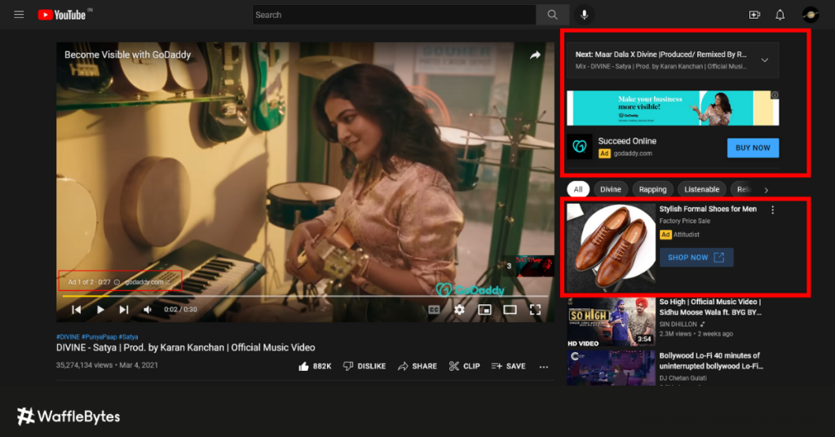
Benefits of Advertising on YouTube
1. Large Audience
YouTube is the second-largest search engine after Google.
It has over 2 billion monthly users. This helps businesses reach people all over the world or a specific group of people.
2. High Engagement
Videos are more interesting than text or images.
Creative and eye-catching video ads can easily grab people’s attention.
3. Targeted Advertising
YouTube allows businesses to choose who will see their ads.
You can target people based on:
- Age and gender
- Interests
- Location
- Online behavior
- Specific videos or channels
This helps you reach the right audience.
4. Cost-Effective
YouTube ads are usually cheaper than TV ads.
You can set your own budget.
In many cases, you only pay when someone watches your ad for 30 seconds or clicks on it.
5. Measurable Results
YouTube provides detailed reports.
You can track:
- Views
- Clicks
- Conversions
- Return on Investment (ROI)

How to Monetize on YouTube ?
Monetize means earning money from your YouTube videos.
You can start making money on YouTube when you join the YouTube Partner Program and meet the required rules (like minimum subscribers and watch hours).

Ways to Earn Money on YouTube
- Ads
You earn money when ads play on your videos and people watch or click on them.
- Channel Memberships
Viewers can pay a monthly fee to support your channel. They get special benefits like badges or exclusive content.
- Super Chat & Super Stickers
During live streams, viewers can pay to highlight their messages.
- Selling Products (Merchandise)
You can sell your own products like T-shirts, mugs, or other items.
- Brand Sponsorships
Companies may pay you to promote their products in your videos.

Meaning: Monetizing on YouTube means turning your videos into a source of income by using ads, memberships, or other money-making features.

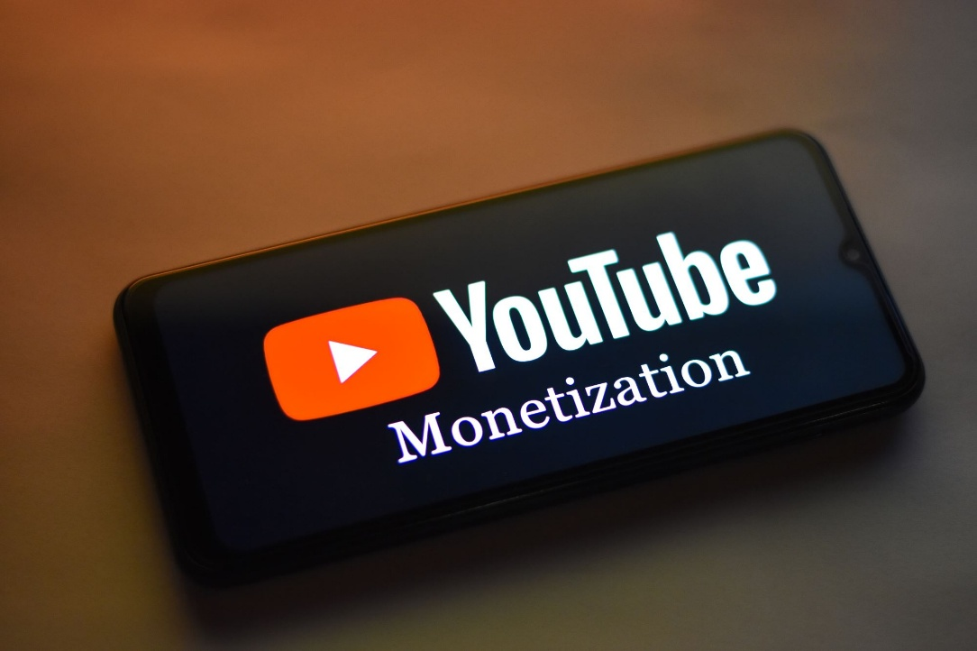

Assignment

Q1. Best targeting for local YouTube ads?
A) Worldwide
B) Country-wide
C) Radius targeting
D) Only keywords

Q2. Best ad length for local promotion?
A) 5–15 seconds
B) 2 minutes
C) 10 minutes
D) 30 minutes

Q3. Best way to grow subscribers?
A) Awareness ads
B) Promote best-performing video
C) Random video
D) No targeting

Q4. Best campaign for app installs?
A) Search campaign
B) App Campaign
C) Display only
D) Awareness

Q5. Best audience for retargeting?
A) Random audience
B) People who watched 50%+ of your video
C) Entire country
D) Kids channel viewers

