Module 2 - Design and Content of e - Mail Marketing

Email marketing success depends mainly on good design and strong content. If an email looks attractive and gives useful information, people are more likely to open and click it.

1. Email Design
Email design means how the email looks — layout, colors, images, buttons, and overall structure.
A. Clear Layout (Simple Structure)
A good email should have:
- Logo at the top
- Attractive headline
- Main message with image
- Call-to-Action (CTA) button
- Contact details and unsubscribe link
Example:
Amazon India sends sale emails with:
- Big banner image
- “Shop Now” button
- Simple product sections
👉 Simple layout = easy to read.

B. Mobile-Friendly Design
In India, most users check emails on mobile phones.
So emails must:
- Load fast
- Have short text
- Have large buttons
- Be easy to scroll
Example:
Flipkart designs emails mainly for mobile users during Big Billion Days Sale.
✅ Best Practice: Always use responsive design.

C. Attractive Subject Line
The subject line decides whether people open the email or ignore it.
Good subject lines:
- Are short (6–10 words)
- Create urgency
- Mention offers
Examples:
- “Diwali Sale – 60% OFF Today!”
- “Last 3 Hours Left!”
Real-life Example:
Myntra uses urgent subject lines during End of Reason Sale.

D. Clear Call-to-Action (CTA)
CTA tells the reader what to do.
Examples of CTA:
- Shop Now
- Book Now
- Download Now
- Claim Offer
CTA buttons should:
- Be bright in color
- Be easy to click
- Appear 1–2 times only
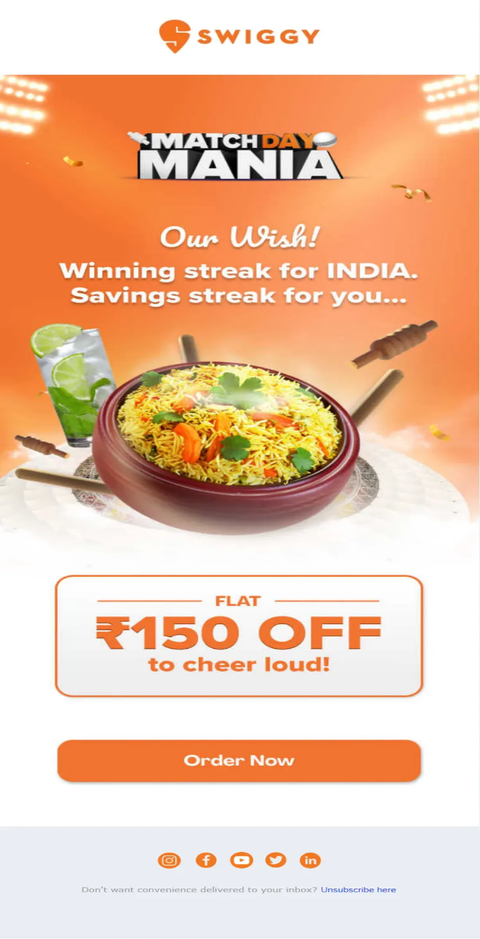
Example:
Zomato uses “Order Now” button clearly in red color.

2. Email Content
Content means the message written inside the email.

A. Personalization
Emails should feel personal.
Instead of:
Dear Customer
Use:
Hi Rahul,
Example:
Swiggy sends emails like:
“Rahul, your favourite biryani is waiting!”
✅ Best Practice: Use customer’s name and past purchase data.

B. Short and Clear Message
Do not write long paragraphs.
Use:
- Bullet points
- Short sentences
- Simple language
Indian users prefer quick reading.

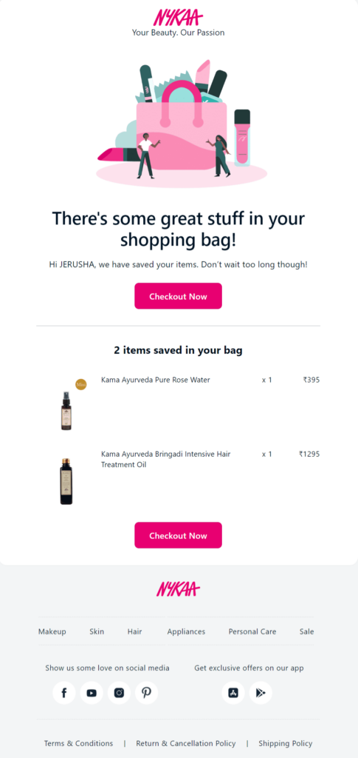
C. Relevant Offers
Send offers based on customer interest.
Example:
- If someone buys shoes, send shoe offers.
- If someone orders food often, send food coupons.
Nykaa sends beauty product emails only to interested users.

D. Value-Based Content (Not Only Sales)
Every email should not just sell. Some emails should give useful information.
Examples:
- Beauty tips
- Fitness advice
- Study tips
- Festival greetings
Example:
Byju's sends exam tips and learning resources, not just course promotions.

3. Best Practices of Email Marketing Design & Content
1. Use Simple Language
Avoid difficult words.
2. Keep Subject Line Catchy
Make users curious.
3. Add One Main CTA
Too many buttons confuse users.
4. Optimize for Mobile
Very important in India.
5. Use Images but Don’t Overload
Too many images may go to spam.
6. Follow Legal Rules
Companies must follow the Digital Personal Data Protection Act 2023 and provide unsubscribe option.
7. Test Before Sending
Send test email to check:
- Spelling errors
- Broken links
- Image loading

Example: Zomato Marketing e-mail

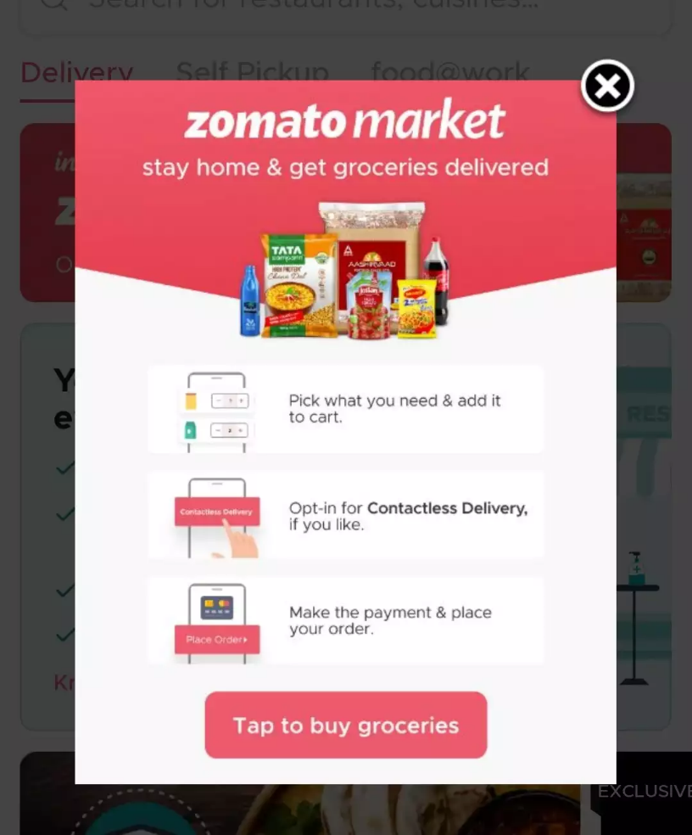

Assignment

Ques 1: What does Email Design mainly refer to?
A. Only writing long paragraphs in emails
B. The look and structure of the email
C. Sending emails without images
D. Writing only promotional offers

Ques 2: A good email layout should start with the ________ at the top.

Ques 3: Why is mobile-friendly email design important in India?
A. Most people read emails on desktop computers
B. Most users check emails on mobile phones
C. Emails cannot be opened on laptops
D. Mobile phones cannot open images

Ques 4: The ________ line is the first thing a user sees before opening an email.

Ques 5: What does CTA stand for in email marketing?
A. Customer Tracking Action
B. Call-to-Action
C. Click-to-Advertise
D. Content Target Area

