Module 3 - Sending Bulk e - Mails

Sending bulk emails means sending one email message to many people at the same time. Instead of sending emails one by one, businesses send a single message to a large list of customers or subscribers. This method is widely used in email marketing to quickly share information, promotions, or updates with many people.
Bulk emails help companies communicate with customers easily and efficiently. With the help of email marketing tools, businesses can reach thousands or even millions of people in just a few minutes.

Key Points
1. Large Audience Reach
Bulk emails allow companies to send messages to a very large number of people at once. This saves a lot of time compared to sending individual emails.
Example:
A clothing brand sends an email about a Diwali sale to 50,000 customers at the same time.

2. Common Uses
Businesses use bulk emails for many purposes such as:
- Product promotions – informing customers about discounts or new products.
- Newsletters – sharing company news, tips, or updates regularly.
- Event announcements – inviting people to webinars, workshops, or sales events.
- Service updates – informing users about new features or improvements.
Example:
A gym sends a bulk email announcing a New Year fitness program to all its members.

3. Automation Tools
Businesses usually send bulk emails using email marketing tools. These tools help to:
- store and manage contact lists
- design professional emails
- schedule emails to send later
- track how many people opened the email
Some commonly used tools are Mailchimp, Constant Contact, Brevo, and Zoho Campaigns.
Example:
A company schedules a newsletter to be sent every Monday morning automatically.

4. Personalization
Even though the same email is sent to many people, businesses can personalize the message using customer data.
For example, the email can automatically include:
- the customer’s name
- recommended products based on past purchases
- special offers for loyal customers
Example:
Instead of writing “Dear Customer”, the email says “Dear Rahul”.

Zoho for Bulk Email Marketing
Zoho Campaigns is the email marketing tool in the Zoho ecosystem used for sending bulk emails, newsletters, and promotions.

Important Note
- Regular Zoho Mail is for normal emailing and has limits (like around 100 recipients per message), so it is not ideal for bulk marketing.
- For marketing campaigns, you should use Zoho Campaigns instead.
✔ Conclusion:
Zoho Campaigns is a simple, free, and reliable tool for beginners who want to send bulk emails.

Visit: https://www.zoho.com/campaigns/

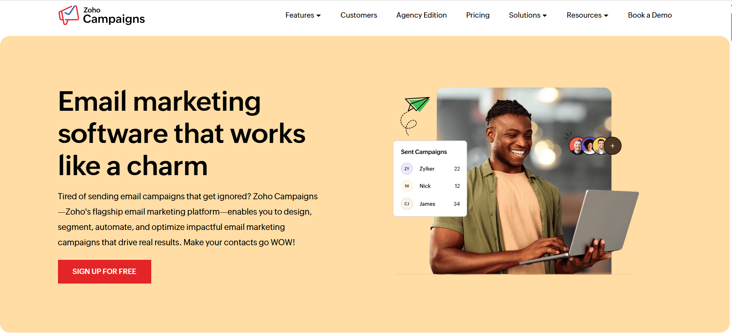

Step-by-step instructions to use Zoho for sending bulk emails using Zoho Campaigns.

1. Create a Zoho Account
- Go to the Zoho Campaigns website.
- Click Sign Up.
- Enter your name, email address, and password.
- Verify your email to activate the account.
Now your Zoho account is ready.
2. Create a Mailing List
A mailing list is the group of people who will receive your emails.
Steps:
- Log in to Zoho Campaigns.
- Go to Contacts.
- Click Create Mailing List.
- Enter:
  - List Name (example: Customers List)
  - Description
- Save the list.

3. Add Email Contacts
Now add the people who will receive your emails.
Steps:
- Open your mailing list.
- Click Add Contacts.
- You can:
  - Type emails manually
  - Upload a CSV/Excel file
  - Copy-paste email addresses.
Example contact details:
- Name
- Email address
After uploading, all contacts will appear in the list.

4. Create an Email Campaign
A campaign is the email message you want to send.
Steps:
- Click Campaigns.
- Select Create Campaign.
- Choose Regular Campaign.
- Enter:
  - Campaign Name
  - Email Subject (example: Big Summer Sale)
  - Sender Email Address.

5. Design the Email
Zoho provides ready templates.
Steps:
- Choose Email Template.
- Use the drag-and-drop editor.
- Add:
  - Text
  - Images
  - Buttons
  - Links.
Example content:
- Greeting message
- Product promotion
- Discount information.

6. Select the Audience
Now choose who will receive the email.
Steps:
- Click Select Recipients.
- Choose your Mailing List.
- Confirm the selected contacts.

7. Preview and Test the Email
Before sending:
- Click Preview to see how the email looks.
- Send a test email to yourself.
- Check formatting and links.

8. Send or Schedule the Email
Final step:
- Click Send Now to send immediately.
- Or choose Schedule to send later (example: tomorrow at 10 AM).
Zoho will now send the email to all contacts in the list.

9. Check Email Performance
After sending, you can track results.
Go to Reports to see:
- Open Rate (how many opened the email)
- Click Rate (how many clicked links)
- Unsubscribes

Example:
A company creates a campaign called “Festival Sale” and sends it to 1,000 customers at once using Zoho Campaigns.

Assignment

Ques 1: What does sending bulk emails mean?
A. Sending emails to one person at a time
B. Sending one email to many people at the same time
C. Sending emails only to employees
D. Sending emails without internet
Ques 2: Why do businesses use bulk emails?
A. To reduce communication
B. To send messages to many customers quickly
C. To block customers
D. To delete email contacts

Ques 3: Which of the following is a common use of bulk email marketing?
A. Sending handwritten letters
B. Product promotions
C. Phone calls
D. Newspaper advertisements

Ques 4: Which of the following is an email marketing automation tool?
A. Microsoft Paint
B. Mailchimp
C. Google Maps
D. Notepad

