Module 5 - Writing Effective SMS Content

Writing effective SMS content means creating short, clear, and attractive text messages that encourage customers to read the message and take action (like buying a product, visiting a website, or using a discount).
Because SMS messages are very short (about 160 characters), the message must be simple, direct, and engaging.

Key Elements of Effective SMS Content
1. Keep the Message Short and Clear
SMS should be easy to read and understand quickly.
❌ Bad Example
“Hello dear customer, we would like to inform you that we have started a promotional offer that you may find interesting.”
✔ Good Example
“50% OFF on all shoes today! Visit our store now.”
Short messages are more effective because people read them quickly.

2. Use a Clear Call-to-Action (CTA)
A Call-to-Action tells customers what to do next.
Examples of CTA:
- Shop Now
- Order Today
- Click Here
- Visit Store
- Use Code
Example SMS:
“Weekend Sale! Get 30% OFF. Shop now at our website.”

3. Personalize the Message
Adding the customer’s name or preferences makes the SMS feel more personal.
Example:
“Hi Rahul! Your favorite pizza is 25% OFF today at Domino’s.”
Personalized messages often get better response rates.

4. Create Urgency
Encourage customers to act quickly.
Use words like:
- Today
- Limited Offer
- Last Chance
- Only 24 Hours
Example:
“Last day! Get 40% OFF on electronics. Shop now.”
5. Include an Offer or Value
Give customers a reason to take action.
Examples:
- Discounts
- Free delivery
- Coupons
- Rewards
Example:
“Use code SAVE20 and get 20% OFF your next order.”

Example of Effective SMS Content
Example for a clothing store:
“Flash Sale! Get 40% OFF on jackets today only. Shop now: www.store.com”
Why it is effective:
- Short message
- Clear offer
- Urgency (today only)
- Call to action (shop now)

TextMagic Platform
TextMagic is an SMS marketing and business messaging platform. It allows businesses to send SMS messages, promotional texts, alerts, and notifications to customers directly from a computer or mobile device.
Businesses use TextMagic to:
- Send bulk SMS marketing campaigns
- Send transactional messages
- Communicate with customers quickly
It is widely used by small businesses, startups, and marketing teams.
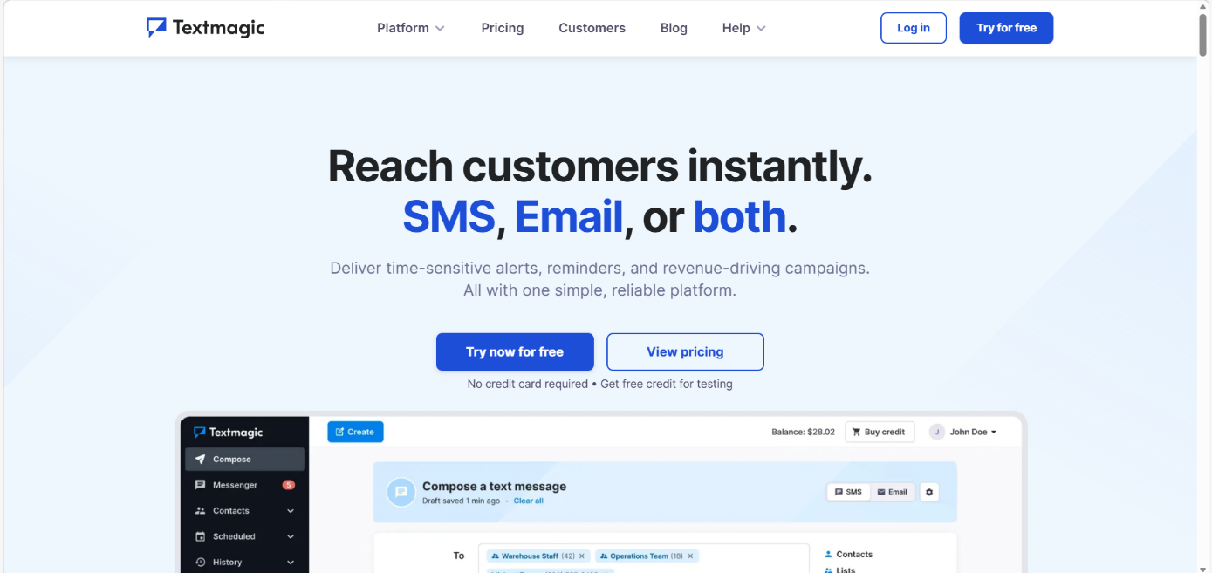

1. What TextMagic Does
TextMagic helps companies communicate with customers using SMS and email from one platform.
Example uses:
- Sending discount offers
- Sending appointment reminders
- Sending order confirmations
- Customer support messages
Example SMS from TextMagic:
“Hi! Get 20% OFF on your next purchase. Use code SAVE20 today.”

2. Main Features of TextMagic
1. Bulk SMS (Mass Texting)
Businesses can send one message to many customers at the same time.
Example:
A clothing store sends:
“Flash Sale! 50% OFF today. Visit our store.”
Benefits:
- Saves time
- Reaches thousands of customers quickly

2. Two-Way Messaging
Customers can reply to the SMS, and businesses can respond.
Example:
Business sends:
“Your order has been delivered. Reply YES to confirm.”
Customer replies:
“YES”
This creates direct communication between business and customer.

3. Contact Management
TextMagic allows businesses to store and manage customer phone numbers.
Features:
- Create contact lists
- Import contacts from Excel or CSV (Comma Separated Values)
- Organize customers into groups
Example groups:
- New customers
- VIP customers
- Newsletter subscribers

4. Scheduled SMS
Businesses can schedule messages for a future time.
Example:
A restaurant schedules SMS for Friday evening:
“Weekend Special! Buy 1 Pizza Get 1 Free.”
The message will automatically send at the selected time.

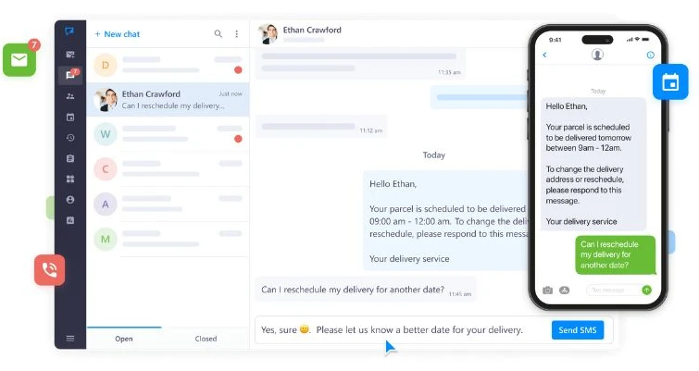

5. SMS Templates
Businesses can create pre-written messages to save time.
Example templates:
Template 1 – Sale
“Get 30% OFF today. Shop now!”
Template 2 – Reminder
“Reminder: Your appointment is tomorrow at 10 AM.”

6. Delivery Reports and Analytics
TextMagic shows reports about SMS campaigns, such as:
- How many messages were sent
- How many were delivered
- Customer replies
This helps businesses measure marketing performance.

SMS Examples from Well-Known Brands
1. Domino's Pizza
Example SMS:
“Hungry? 🍕 Get Buy 1 Get 1 Free Pizza today only! Order now from the Domino’s app.”

2. Amazon
Example SMS:
“Mega Deal Alert! ⚡ Up to 70% OFF on electronics today. Shop now before the deal ends!”

3. Flipkart
Example SMS:
“The Big Billion Days sale is LIVE! 🛍️ Grab amazing deals before they’re gone!”

4. Swiggy
Example SMS:
“Late night cravings? 🌙 Get ₹150 OFF on your next order. Use code: HUNGRY.”

5. Uber
Example SMS:
“Need a ride? 🚗 Get 20% OFF your next trip. Book now on the Uber app.”

6. Nike
Example SMS:
“Run faster this season! 🏃‍♂️ 30% OFF on running shoes today only. Shop now!”

Assignment

Ques 1: Which of the following creates urgency in SMS messages?
A. Words like “Limited Offer” or “Only Today”
B. Writing long sentences
C. Avoiding numbers and offers
D. Sending the same message multiple times

Ques 2: Which of the following is an offer or value-based SMS?
A. “Reminder: Your appointment is tomorrow”
B. “Use code SAVE20 and get 20% OFF your next order.”
C. “Hello, how are you?”
D. “Your order has been delivered.”

Ques 3: Which platform allows businesses to send bulk SMS, manage contacts, and track SMS campaigns?
A. Mailchimp
B. TextMagic
C. WhatsApp
D. Zoho Mail

Ques 4: Which feature of TextMagic allows businesses to send one message to many customers at the same time?
A. Scheduled SMS
B. Two-Way Messaging
C. Bulk SMS (Mass Texting)
D. Contact Management

