Module 2 - Creating Designs with Shapes in MS Word

Definition
The Insert Menu in MS Word is a feature that allows users to add various elements such as tables, images, charts, text boxes, and other objects into a document. This menu helps enhance the document's structure, readability, and visual appeal.

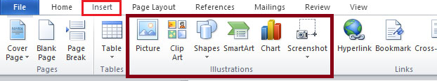
Illustrations Group
The Illustrations group is a set of tools in the Insert tab of MS Word that allows users to add visual elements like images, shapes, charts, and SmartArt to documents.

Shapes
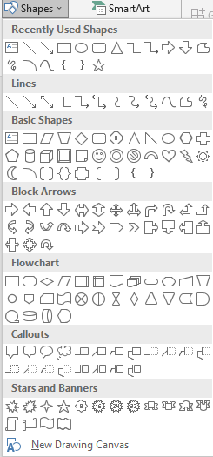
In MS Word, Shapes are pre-designed drawing objects that you can insert into your document to enhance its appearance. These shapes include lines, arrows, rectangles, circles, stars, callouts, flowchart symbols, and more.
There are total of 8 sections in shapes:
- Lines
- Rectangles
- Basic Shapes
- Block Arrows
- Equation Shapes
- Flowcharts
- Stars and Banners
- Callouts

Use of Shapes in MS Word
We use Shapes in MS Word to make documents
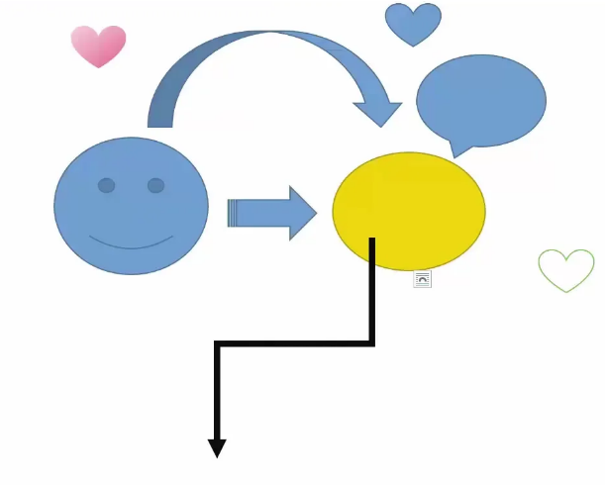
more visually appealing, organized, and easy
to understand. Here are some key reasons
why shapes are used:

To Enhance Presentation
- Shapes like arrows, boxes, and circles can
- highlight important points in a document.
- Used for decorative elements to improve
- document design.

To Create Diagrams & Flowcharts
- Shapes help in creating organizational charts,
- process diagrams, and workflows.
- Useful for business documents, educational
- materials, and technical reports.

Add Text in a Shape

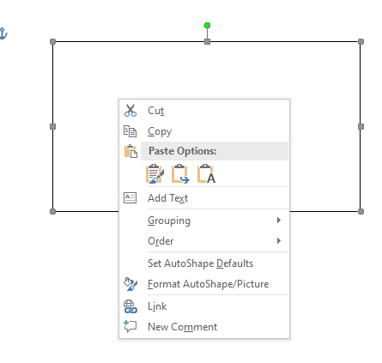
Step-by-Step Guide:
Insert a Shape:
- Open MS Word and go to the Insert tab.
- Click on Shapes (in the Illustrations group).
- Choose a shape and draw it in your document.
Add Text to the Shape:
- Right-click on the shape.
- Select Add Text (or Edit Text).
- A cursor will appear inside the shape.
Type Your Text:
- Start typing, and the text will appear inside the shape.

Rotate a Shape in MS Word
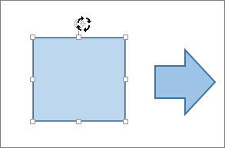
You can rotate a shape in MS Word using the following methods:
Method 1: Using the Rotate Handle (Quick Method)
Insert a Shape:
- Go to the Insert tab → Click Shapes → Select and draw a shape.
Rotate the Shape:
  - Click on the shape to select it.
  - A circular arrow (🔄) appears at the top of the shape.
  - Click and drag this handle left or right to rotate the shape freely.

Helping Tool of Shapes
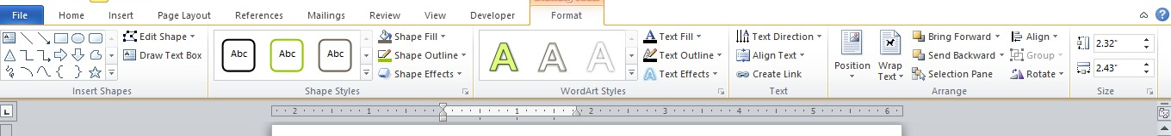
The Format Menu in MS Word provides tools to customize the appearance of text, images, shapes, and other elements in a document. It helps improve readability, design, and overall presentation.

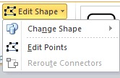
Edit Shape in MS Word
The "Edit Shape" feature in MS Word allows users to modify an existing shape by changing its form, adjusting its points, or converting it into another shape. This is useful for customizing diagrams, flowcharts, and creative designs.

Reroute Connectors
A connector is a line that links two shapes. Unlike a normal line, a connector stays attached to the shapes even if you move them.
Reroute Connectors automatically change the connector’s path to avoid overlaps or create the shortest path between shapes.

This is especially useful in flowcharts, diagrams, and organizational charts where connectors need to avoid overlapping or tangled paths.

How to Use Reroute Connectors
1. Insert Shapes
- Go to Insert → Shapes → New Drawing Canvas.
- Select a shape (e.g., Rectangle, Oval).
- Draw two or more shapes on your slide/document.

2. Add Text to Shapes
- Right-click a shape.
- Choose Add Text.
- Type your desired label (e.g., "Start" and "End").

3. Connect Shapes
- Go to Insert → Shapes and select a Connector (like Elbow Connector or Straight Connector).
- Hover over the first shape until you see connection points (small dots).
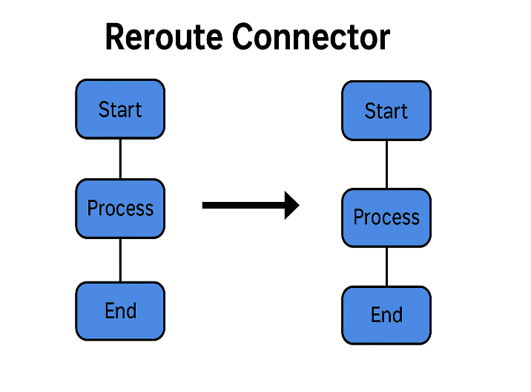
- Click a connection point on the first shape, then drag to a connection point on the second shape.

4. Reroute the Connector
- If you move the shapes, the connector may twist awkwardly.
- To fix it:
  - Select the connector line.
  - Right-click and choose Reroute Connector.
  - The connector will automatically adjust to take a cleaner or shorter path.

NOTE: This is especially useful in flowcharts and diagrams to keep them neat.

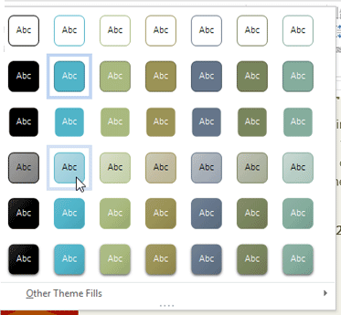
Shape Styles in MS Word
Shape Styles in MS Word are predefined formatting options that allow users to customize the appearance of shapes, such as rectangles, circles, and arrows.

Shape Fill in MS Word
Shape Fill in MS Word lets you add color, gradient, texture, or pattern to a shape’s interior for customization. It offers various options to enhance the visual appearance of shapes and make them more dynamic in your document.

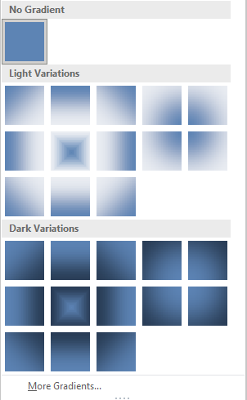
Gradient – Shape Fill
A Gradient in MS Word is a color effect that blends two or more colors smoothly within a shape. It enhances the visual appeal of shapes, making them more attractive and professional.

More Gradient – Shape Fill
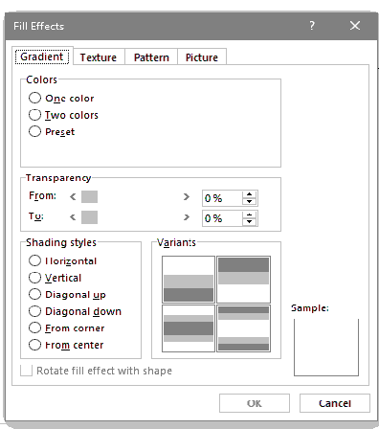
"More Gradients" in MS Word allows you to create custom gradient fills for shapes, text, or backgrounds. It offers advanced options to adjust colors, direction, and transparency for a personalized gradient effect.

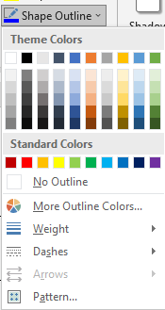
Shape Outline
In Microsoft Word, a shape outline refers to the border or the edge of a shape, such as a rectangle, circle, or any other shape inserted into the document. The outline helps define the boundaries of the shape and can be customized in terms of color, thickness, style, and other visual properties.

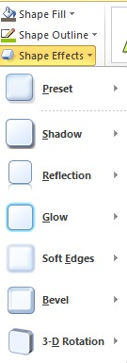
Shape Effects
In Microsoft Word, Shape Effects are special visual enhancements that can be applied to shapes, such as text boxes, autoshapes, or drawn objects. These effects can make your shapes stand out and improve the overall design of your document.

WordArt Styles
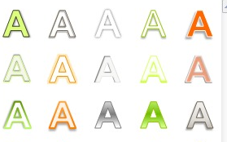
WordArt Styles in Microsoft Word are pre-designed text effects that let you create decorative and visually appealing text. These styles include:
- Text Fill – Allows you to fill the text with solid colors, gradients, textures, or pictures.
- Text Outline – Adds a border around the text with different colors and thicknesses.
- Text Effects – Applies effects like shadows, reflections, glows, 3D rotation, and bevels.
- Transform – Lets you bend, stretch, or shape the text into different forms (e.g., wavy, circular).

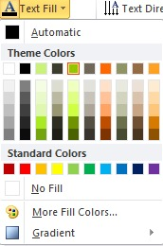
Text Fill

Text Fill is a formatting feature in Microsoft Word that allows you to change the color, gradient, texture, or even use an image inside the text. It is commonly used in WordArt to create decorative text.

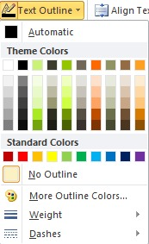

Text Outline

Text Outline is a feature in Microsoft Word that allows you to add a border or stroke around text. It is commonly used in WordArt to make text stand out with different colors, thicknesses, and styles.

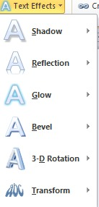
Text Effects

Text effects in MS Word enhance text with visual styles such as shadows, glows, reflections, and 3D effects. These effects help make text stand out and improve its visual appeal in documents.

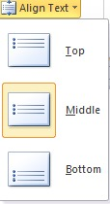
Text Direction

Text Direction in Microsoft Word allows you to change the orientation of text in tables, text boxes, and shapes. You can rotate the text vertically, horizontally, or at an angle.

Align Text

Text Alignment in Microsoft Word allows you to position text horizontally and vertically within a document, table, text box, or shape.

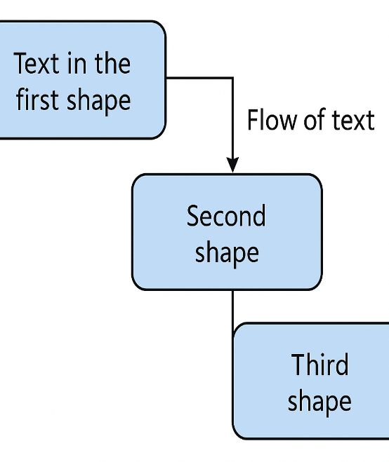
Create Link
You can add a hyperlink to text inside a text box in Microsoft Word to link to a website, email, another document, or a specific section within the same document.

Linking Shapes with Flowing Text in Word

Step 1 – Insert the First Shape
- Go to Insert → Shapes.
- Pick a shape (e.g., Rectangle, Rounded Rectangle, or any closed shape).
- Draw the shape on your page.
- Right-click → Add Text (or just start typing).

Step 2 – Insert the Second and Third Shapes
- Repeat the same steps to insert two more shapes anywhere in the document.
- Add placeholder text if you like, or leave them empty for now.

Step 3 – Link the Shapes Together
- Click inside the first shape to select it.
- On the Shape Format tab (appears when the shape is selected), find the Create Link button in the Text group.
  - In some versions of Word, you may need to go to Drawing Tools → Format to see it.
- Click Create Link — the cursor changes to a pitcher icon.
- Click inside the second shape.
- Repeat the process:
  - Select the second shape.
  - Click Create Link.
  - Click inside the third shape.

How It Works
- If the first shape’s text overflows, the extra text flows automatically into the second shape, then into the third.
- Resize or move shapes freely — the links still work.
- Change colors and outlines via Shape Format → Shape Fill / Outline.

Position
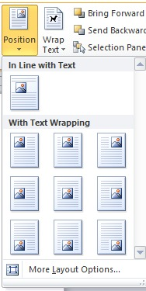
In Microsoft Word, you can control the position of text, text boxes, images, and other objects to create a well-organized document layout.

Wrap Text
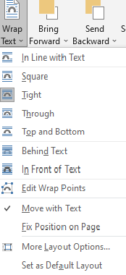
Wrap Text in Microsoft Word controls how text flows around images, text boxes, tables, and other objects. This feature helps position objects more flexibly within a document.

Bring Forward
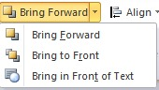
The "Bring Forward" option in Microsoft Word is used to move objects (such as images, text boxes, shapes, or WordArt) to the front of the document layout, placing them above other elements.

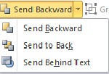
Send Backward
The "Send Backward" option in Microsoft Word is used to move objects (such as images, text boxes, shapes, or WordArt) behind other elements in a document. This helps organize overlapping objects.

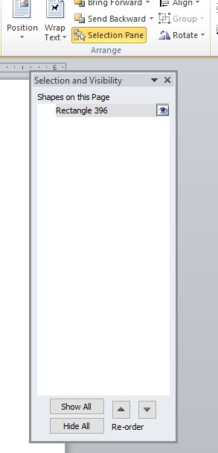
Selection Pane
The Selection Pane in MS Word allows you to view, select, and organize objects such as shapes, text boxes, and images in your document. It provides a simple way to hide, show, or reorder objects for better document management.

Group in MS Word
The Group feature in Microsoft Word allows you to combine multiple objects (such as images, text boxes, shapes, or WordArt) into a single unit. This makes it easier to move, resize, or format them.

Rotate in MS Word
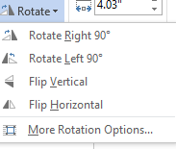
In MS Word, the "Rotate" feature lets you turn shapes or objects to any angle, either manually or by using preset options like 90-degree rotations. This helps adjust the orientation of shapes to fit your document's design.

Align in MS Word
In MS Word, the "Align" feature allows you to position shapes relative to each other or the page, ensuring they are evenly spaced and organized.

Height and Width
In Microsoft Word, you can adjust the height and width of images, text boxes, shapes, tables, and other objects to ensure they fit properly in your document.

Make this Assignment using Shapes in MS Word

Your Text Here

